Date:
Verb to be and vocabulary 1
- Match to make sentences.
I
He are
We is in London.
They am

- Make a questions and answer.
Your mum/working/? Answer: Yes
_____________________________________________________
She/in Britain/? Answer: No
_____________________________________________________
You/angry with he/? Answer: No
_____________________________________________________

- Complete the text. Y-affirmative, N-negative
Hello, I’m Mike. I___ (N) from England, I___(Y) from New York. My mum works in a company, she___ (N) the cleaning woman, she___ (Y) the secretary.

- Match the pictures with the words.
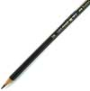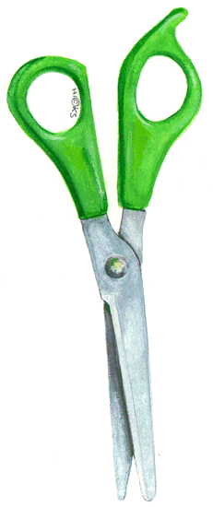

pencilcase notebook pencil scissors

5- Read the text and answer the questions.
Hello, I’m Megan. I’m thirteen years old. I live in London.
My classmates are Bill and Sally. We’re going to the 1C class.
My favourite subjects are French and Geography.
I’ve got two brothers. Their names are Phil and Jake. I’ve also got a sister call Jenny.
a) What is her name?
___________________________________________________________
b) She lives in...
___________________________________________________________
c) Her favourite subjects are...
___________________________________________________________
d) What are her brothers and sisters name?
___________________________________________________________

6- Describe this person.


